Acupuncture doubles the success of IVF
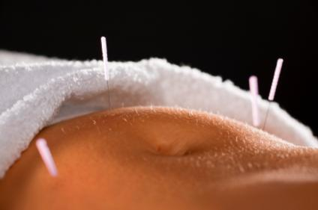

Scientists at Homerton University Hospital studied 127 women aged between 23 and 43, on their first or second cycle of IVF. They were split into two groups – one having four sessions of acupuncture while undergoing IVF, and the other having none. Among the treatment group, 46.2 per cent conceived – more than twice as many as in the other group, where only 21.7 per cent of the women became pregnant (Randomised controlled trial; Gillerman et al.).

The true mechanism of the acupuncture treatment is as yet unknown. The effect may be due to a placebo effect, for example the additional attention received by the acupuncture group as opposed to controls may have had a positive psychological influence. Or the positive effect may be due to specific effects of acupuncture, such as changes in biochemical factors including neuropeptides, pituitary hormones, endorphines, serotonine and many others as measured in a variety of earlier studies. The complexity of the effect acupuncture has on many biochemical factors make it very difficult to assess a clear cause and effect pathway.
Setting aside the question of mechanism acupuncture seems to be amazingly effective to increase IVF success.
The study was presented at the ESHRE (European Society of Human Reproduction and Embryology) in July 2016 by Karin Gillerman MBAcC.
- http://www.telegraph.co.uk/news/2016/07/04/acupuncture-doubles-chance-of-having-a-baby-with-ivf-study-sugge/

