Easing Through the Menopause

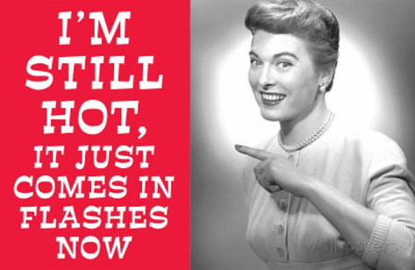

It’s International Women’s Day on the 8th of March and we have much to celebrate. We have an increasingly more powerful collective voice, creating waves of change in so many areas. The theme this year is #betterbalance and there is so much more to be done to create a gender balanced world. Women in their middle age and older are often underrepresented, take a look at the IWD gallery for starters, but I am pleased to see that one of the IWD events is on menopause, ‘Why the menopause is Everyone’s Business’. It is a topic that deserves to be better understood by everyone, so that women are supported at work and at home through this period of their lives.

Menopause can be extremely disruptive, with 7 out of 10 women in the UK experiencing debilitating symptoms. The wide ranging emotional and physical symptoms are often not recognised as being hormonally related with women feeling that they are going off the rails emotionally or physically falling apart. Hot flushes, sweats, sleep problems, mood swings, changes in libido, dryness of skin, thinning hair, vaginal dryness, joint and muscle pain and a slowed metabolism leading to weight gain, to name just a few symptoms. There is also an increased risk of osteoporosis and cardiovascular problems. It affects family life, relationships and work, in fact it can cause turmoil in just about every area of a woman’s life.

HRT can help with many of the symptoms and there are now many options. With specialist advice to tailor them to individual needs and monitoring they are now much safer than they were, but they are not a choice for everyone. For those women who cannot or do not wish to take HRT, acupuncture can help to ease them through this turbulent time and alleviate many of the physical and emotional symptoms.

So how can acupuncture help?
A recent randomised controlled trial from Denmark published in the BMJ looked at the effect of weekly acupuncture on hot flushes and a range of other commonly experienced symptoms. After just 2 weekly sessions hot flushes, emotional well-being and skin improved, after 5 weekly sessions sweating reduced, sleep quality was better and other physical symptoms also improved.

Studies of this kind, in order to be replicable, use the same set of points for every woman. In a clinic setting the choice of points would be adapted to the individual needs of the woman so the results are likely to be even more beneficial. Acupuncture also releases endorphins which can lift mood and help to alleviate some of the emotional aspects of menopause.

What else can you do to help?

It is helpful to adapt your lifestyle to your changing needs. Here are a few suggestions:

- Reduce intake of alcohol, caffeine, sugar, chocolate and spicy foods which can trigger hot flushes and aggravate other symptoms, and don’t smoke.

- Follow a healthy, balanced, varied, fresh, wholefood diet. Nutrition is a broad subject and everyone’s eating habits are different, so I would recommend seeking the advice of a specialist.

- Stay well hydrated by drinking plenty of water, don’t wait until you feel thirsty.

- Keep your bones strong with weight bearing exercise, like walking, dancing and jogging plus adequate calcium and vitamin D which may be hard to get from diet alone. Don’t forget the upper body, Yoga is an excellent weight bearing exercise.

- Stretch regularly. Yoga, Tai Chi, Qi Gong and Pilates all help to maintain flexibility. The breathing and mindful focus of these exercises deepens relaxation and calms the mind.

- Make time for fun, laughter and social time with friends and family.

- Take time to prioritise looking after yourself and do things that bring you joy.

Don’t ignore your symptoms and put up with them. Get some help and get your life back on track.

Lund KS, Siersma V, Brodersen J, et al Efficacy of a standardised acupuncture approach for women with bothersome menopausal symptoms: a pragmatic randomised study in primary care (the ACOM study) BMJ Open 2019;9:e023637. doi: 10.1136/bmjopen-2018-023637

