Happier Periods and a Healthier You!
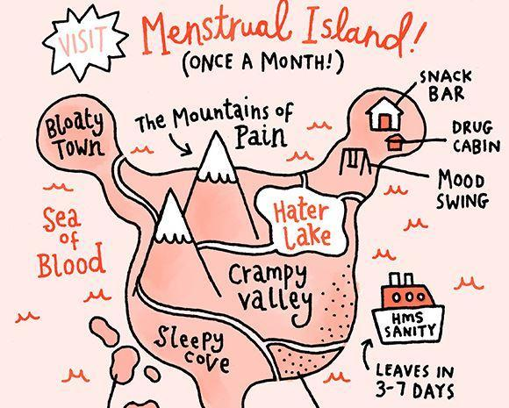
Cramps, heavy bleeding, sore breasts, back pain, poor sleep and mood swings - periods can be a time of dread and misery for many women. Do you pop a pill and struggle on? Does it interfere with what you are able to do? Do you collapse on the sofa with a hot water bottle and work your way through a month’s supply of chocolate? You don’t have to just get through it, you can change the nature of your periods. I have many clients who have had dramatic long lasting improvements in their cycles. Read on to find out how acupuncture can help.
Our menstrual cycles often display patterns that reflect our wider health and from a Traditional Chinese Medicine (TCM) perspective they provide a very useful insight. Rectifying underlying patterns can help to adjust your period as well as helping with other symptoms that may seem unrelated. Even women whose periods are not disruptive, may gain insights into their wider health by looking at their cycles – for example short, light scanty periods may be a sign that you could benefit from more nourishment and may coincide with other symptoms like tiredness, poor concentration and dull headaches.
It is easy to believe that what we experience each month is normal because it becomes what we are used to, even when it verges on the extreme, especially if it has crept up over time. One client in her forties, had been having severe cramps since she was a teenager. They were so bad that she was on several occasions given morphine to deal with the pain. She had a course of acupuncture spread over 3 months and now comes once every 6 weeks or so. Most of her periods are now completely pain free, for the odd one she has mild pain that is easily managed. Unusual periods can also in themselves lead onto other issues, for example heavy blood loss every month can over time lead to anaemia. So don’t just put up with things.
To understand what is influencing the period we take a close look at just about every aspect of the whole cycle and especially the period – length of cycle, length of bleed, blood flow, consistency of the blood and whether or not there are clots, the size of the clots, any pain, the nature and location of the pain and when in the cycle you feel it, likewise with moods throughout the whole cycle. These details are put together with other aspects of your health – your digestion, sleep, energy levels and any other symptoms, for example headaches. Taking your pulse and looking at your tongue also give vital clues.
These finding are then put together to identify patterns of disharmony that in Traditional Chinese Medicine (TCM) relate to Qi, blood and the balance of yin and yang. In biomedical terms these loosely correlate with hormonal levels, adrenal function and a host of other factors that influence our physiology. It can help to pin point issues that may need to be further investigated and diagnosed by your GP. Any bleeding outside your normal period should always be checked promptly with your GP and I would encourage women with any unusual symptoms to consult their GP if they have not already done so. Treatment is focused on you as a whole so it is not just your period symptoms that benefit. A look at lifestyle helps to identify small steps you can take to support treatment – often dietary and exercise adjustments – based on your TCM diagnosis and what you feel is manageable.
Acupuncture is gentle and relaxing – the needles, as fine as a hair, are gently inserted and you just lay back and relax for 20 minutes or so while they work their magic. Well, actually, far from being magic the mechanisms by which acupuncture works are increasingly well understood. Acupuncture stimulates the fascia which triggers a cascade of hormonal and neurological effects that reduce inflammation, affect blood flow and influence the body’s homeostatic self regulating ability to heal itself.
Your period is a wonderful embodiment of your fertility, don’t put up with discomfort or distressing symptoms. Help them feel like a blessing and not a curse.

