Improving Male Fertility Part II:
Steps men can take to boost their fertility

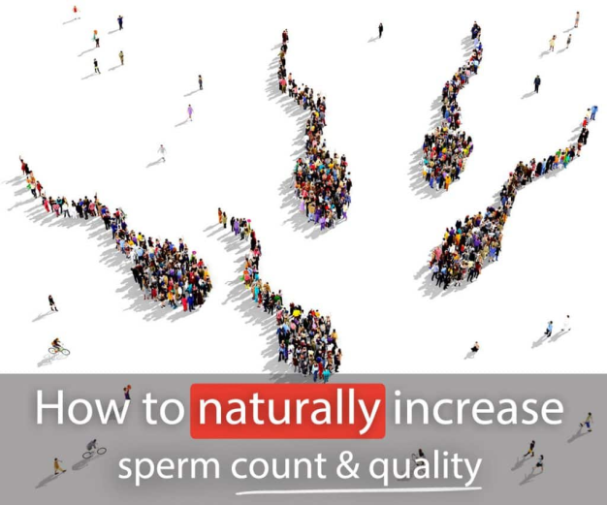
Here we’ll take a look at some of the many things that you can do to help give your fertility a boost with the focus being on sperm and semen quality. This follows on from my previous blog, Improving Male Fertility Part I, which looked at why sperm and semen results that come back within normal ranges are not necessarily an indicator of good fertility.
With the excesses of the festive season behind you, the benefits of a healthy purge may be very welcome for your general health, as well as your fertility. Many of the changes apply to both men and women looking to boost their fertility so working together, supporting and encouraging one another and focussing on what you can do, rather than what you can’t, can make the changes easier. The intention is for this information to be a source of empowerment, certainly not guilt. Focus on making changes that feel manageable and get support when you need it.
So what can you do?
Start with a healthy lifestyle – eat a healthy diet, if possible take dietary supplements for fertility, exercise regularly and reduce exposure to toxins. Men produce sperm all the time and it takes approximately 90 days for the sperm to mature so these measures need to be maintained over the course of 3 months. Increasing the nutritional quality of what you eat and taking supplements will provide the necessary nutrients for optimal sperm and semen production. Reducing exposure to toxins and increasing the amount of antioxidants in your diet will protect the sperm and semen from damage. Even if you end up having IVF and ICSI, you will help to improve the likelihood of success and also support the health of your future babies.
Acupuncture
Have a course of acupuncture. Acupuncture helps fertility and can also be a great support, helping you to relax. It is very gentle, using needles the width of a hair to stimulate the points. Points used are located mainly on the arms, legs, abdomen and back – never in the genitals! Studies have shown that acupuncture can effectively:
- Increase sperm production
- Increase the percentage of healthy sperm
- Improve sperm movement (motility)
- Improve the levels of hormones responsible for fertility
- Increase the rate of pregnancy both in natural and assisted conception
Additionally, you will get support and encouragement to keep doing the things that help you on the path to fatherhood.
Now let’s look in more detail at some of the lifestyle changes that help.
Diet
A healthy diet based on wholesome, organic, unrefined food without harmful additives and chemicals will support fertility, help maintain a healthy weight and in conjunction with exercise improve your overall health. Here are some tips to help men improve their diet for fertility.
Eat more:
- Wholefoods, unrefined and as natural as possible, so whole fruit rather than juice. Whole foods provide the extras like fibre, enzymes and maximum nutrients.
- Slow carbs like wholegrains, beans, peas, lentils and vegetables. They help to avoid blood sugar spikes which in turn can help to regulate metabolism and hormones.
- Plant based foods with plenty of fruit and vegetables, nuts and seeds which are full of antioxidants to protect against free radical damage from Reactive Oxygen Species, a common cause of impaired male fertility.
- Healthy Fats from avocados, olive oil, nuts, seeds, and short lived oily fish (herring, mackerel and wild salmon) which help to reduce inflammation.
- Milk, yoghurt and eggs are good.
- For meat eaters high quality free range poultry and, in moderation, grass fed meat. Eating reduced amounts of meat, and ensuring the meat you do eat is of the highest quality, will help to reduce exposure to toxins and also xenoestrogens, the oestrogen mimicking hormones that are present in the environment.
Try to limit:
- Alcohol as it reduces semen volume and sperm morphology and motility. Keep under the recommended 14 units per week for men and spread them through the week.
- Additives, sweeteners, colours, flavourings and preservatives.
- Saturated fats, sugars and refined carbohydrates.
- Processed meat such as bacon and salami.
- Moderate caffeine intake is fine but you may wish to reduce your intake to support your partner who may be avoiding all caffeine.
Supplements
Supplements have an important role to play in enhancing fertility, especially as so many foods are now depleted of nutrients, however they are not a replacement for a heathy diet. I suggest a high quality formula aimed specifically at male fertility. Vitamen in the Zita West range was formulated by Melanie Brown, a leading authority on nutrition and male fertility. Another good brand is Fertilsan M in the amitamin range which also contains pine bark extract, said to enhance the effects of some of the other ingredients. For more tailored advice on both diet and supplements I would recommend seeing Melanie Brown, who works with both men and women.
Reducing Exposure to toxins
Toxins are widespread in food, the environment including our air and water supply and our exposure is also often higher in certain occupations. Some of the main culprits cited include:
- pesticides, plastics, detergents, solvents, paint fumes and metals including lead and mercury.
- Xenoestrogens which disrupt hormone balance
More research is needed to determine exactly how they are impacting men’s fertility. While we cannot avoid them completely we can take steps to reduce our exposure to some of them, seeking out less noxious alternatives and taking protective measures, for example:
- Delay house decoration and renovation.
- Use natural cleaning products.
- Use protective masks when cycling in polluted areas and choose routes with cleaner air.
- Avoid drinking and eating from plastic containers, especially when they are heated.
- Drink tap water filtered through a simple carbon filter, either fitted to your water supply or using a jug. It removes a significant amount of the oestrogen related compounds.
Exercise and optimal weight
Exercise has multiple benefits. It helps to maintain a healthy weight and the optimal BMI for fertility is between 19-25. It also helps calm the mind and manage stress which has an impact on so many aspects of our health, including fertility. Finding an exercise program that is sustainable is key, so aim for something enjoyable, that you can fit in around your other commitments. Make it something social if that helps. Take the stairs not the lift, incorporate a brisk walk into your commute – it all adds up. Being underweight is also detrimental to male fertility so it is important to get the right balance of diet and exercise for you. It is not advisable to lose weight while undergoing fertility treatment.
Keep your scrotum cool!
- Wear clothes that fit loosely around the groin
- Avoid hot tubs, saunas, hot baths, electric blankets and heated car seats
- Try to avoid sitting for prolonged periods
- Keep the laptop off your lap
Drugs - prescription and recreational
- Avoid recreational drugs especially cigarettes, marijuana and cocaine
- Avoid anabolic steroids, often used to increase muscle mass in body builders
- Have any prescription drugs reviewed by your pharmacist or GP. Those taken for high blood pressure and depression commonly impact on fertility.
Keeping it Fresh
Regular ejaculation is important for keeping your sperm fresh and healthy. Aim for intercourse every day or every other day during the fertile window and the rest of the month ejaculating every 2-5 days has been shown to improve sperm health. Place emphasis on keeping sex fun, loving, exciting and interesting for you both – sex that is recreational will also be procreational! Nurturing your relationship is important so keep talking and doing all the things you enjoy together that help to keep you close.
Stress, depression and relaxation
Stress and depression have an impact on male fertility, and understandably can commonly increase after the diagnosis of a fertility issue or following an unsuccessful round of IVF. They can affect sperm numbers and function and also hormone balance which controls development of sperm. Getting support, exercising and having acupuncture can all help. Interestingly, actively ‘coping’ with stress by being more assertive or confrontational makes matters worse. It increases adrenaline which in turn reduces blood flow to the testes and penis. Put time aside for the things that you enjoy. Take time to relax by yourself, with friends and with your partner. Get help if you feel things are not improving.
When to make changes and when to get tested
As it takes about 90 days for sperm to be produced most of the above changes should be made at least 90 days before you wish to start trying for a baby. Some men may benefit from making changes earlier, for example, if you need to lose a significant amount of weight.
The range of parameters tested varies from place to place with some being far more extensive than others. Fertility investigations and testing are usually not started until you have been trying for at least a year, six months if the woman is over 35. If you fall into this category or are concerned for any other reason then make an appointment with your GP. If you wish to be tested earlier or would like the benefit of more thorough tests and treatment, then I would recommend contacting Dr Sheryl Homa at Andrology Solutions, the only clinic in the UK licensed by the HFEA to focus purely on male fertility. They offer a fully comprehensive semen analysis, as well as other investigations where appropriate, and Dr Homa can advise on tests and discuss the results and next steps with you including referral to a consultant urologist if necessary.
Some of you may go all out and change everything you can, others of you may make a few changes to start with and take it from there. Keep it manageable and remember that help is at hand if you need it. You may be interested in this clip of three men discussing their experiences of struggling to have children which was broadcast on BBC Radio 4 on 11th December 2017 How do men deal with infertility?

