The Allotment, Nature and Holistic Health

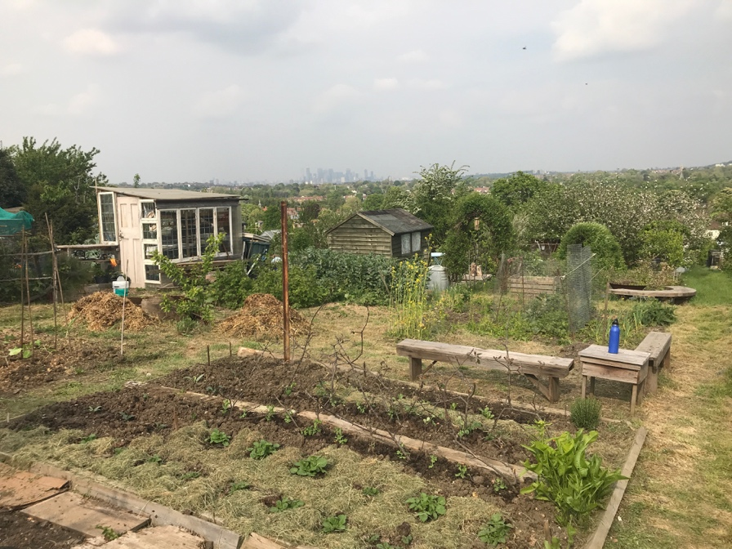

I have recently found an unexpected place of peace, tranquillity and contemplation in the heart of London. It is particularly beautiful at this time of year, with spring flowers, fruit trees in blossom and song birds in full chorus. Sitting on a hill above the worst of the pollution with spectacular far reaching views across the city, it is a world of discovery and unexpected surprises. Today we found lizards beneath some wooden boards. It’s an allotment, or rather a share of one, which is even better and far more manageable, in a stunning location close to Brockwell Park. I frequently use metaphors of nature, landscape and environment to illustrate the way that Chinese Medicine views the body. Working on the allotment has fuelled those ideas.

The allotment is quite different from my garden. More mess and earth, getting down and dirty in the soil, with plenty of muck involved. I’ve learnt a thing or too already from the other plot holders generously sharing tips on what grows well up there and how to improve the soil. It’s clay, which is rich in minerals but heavy, and by adding well rotted horse manure and straw the texture and drainage is improved. It feels good to look at the soil more closely, feel its texture rich in fat worms, and know the difference it will make to the health of the plants and the taste of the produce if the slugs don’t get there first.

The muck is like eating really good fresh vital food, as opposed to processed foods and vitamin pills, the equivalent of chemical fertilisers. An organic approach to gardening builds strength in the plants naturally so that they withstand pests, akin to having a healthy immune system. Nurturing and nudging health in positive directions through good nutrition, appropriate exercise, adequate rest and relaxation, affects how we feel in body, mind and spirit. Even when it comes to genetics, we now know that how we live influences which genes are switched on and off.

People often ask if acupuncture can help, such and such a condition. Of course, acupuncture is better suited to treating some things than others, but it is the bodily landscape that is at the heart of a Chinese Medical diagnosis and treatment, rather than the condition. The landscape - be it hot, cold, dry, damp, stagnant, depleted, etc - creates the conditions in which certain imbalances are more likely to arise and progress. The disease label is very often not as important as the landscape against which it has arisen. Two people with migraines may have very different types, arising from very different bodily landscapes and they will be treated differently. A landscape that gives rise to stomach pains in one person, may cause anxiety in another and the treatments may be very similar. So the landscape, rather than the disease label, is more important when it comes to treating with acupuncture and often has more influence on how easily a health issue will resolve. By addressing the imbalance people often find that their overall health and wellbeing improve, not just the issue that they sought treatment for.

Chinese Medicine sees the body as an interconnected whole, where every part of the body is interrelated, and each part exerts an influence on the whole. With climate change we can see just how delicately balanced and interdependent the whole planet is. This too is reflected in our small allotment, with its lizards, foxes and insect life. Our bodies are not so different, as an example I think of the influence that a healthy gut biome has on brain function.

I find the Daoist view, where the internal landscape of the body is influenced by the same forces that influence nature, to be enlightening, inspirational and nature is a great teacher, as well as a great healer. We often give priority to nurturing our physical health and we can do the same for our mental health and wellbeing. Being out in nature is a soothing counterbalance to the bustle of city life. I have found that tending the allotment and looking out over the view in quiet contemplation, or while hanging out with friends, is food for mind, body and soul, both literally and metaphorically. I certainly wouldn’t do it for economic reasons – at an hourly minimum wage it probably works out about £100 a spud!

